**Merton Credit Risk Model**

*chrome-extension://efaidnbmnnnibpcajpcglclefindmkaj/https://rdrr.io/rforge/ifrogs/f/inst/doc/dtd.pdf*

The Merton Model is used to understand a firm’s risk of credit default. The equity of the firm is modelled as a call option on its assets. This call option is the contract that allows buyer to purchase a stock or another financial asset at a specified price by or on a certain settled date. The assets that generate cash flow for the company can fluctuate over the time. Modelling the equity as a call option on assets indicates that the value of the equity is dependent on the value of the underlying assets.

A firm is financed with both equity and debt. Merton Model gives the probability of default (The likelihood that the firm will be unable to meet its obligations.) We can also find he firm’s debt at various times along with the credit spread.

Company’s outstanding debt plays the role for the strike price. Overall, the underlying idea behind the Merton Model is that **if the value of assets is lower than the value of debt, the equity becomes worthless, indicating that the company may default on its debt obligations. We essentially measure the Distance to Default to assess how far the firm is from the default point.**

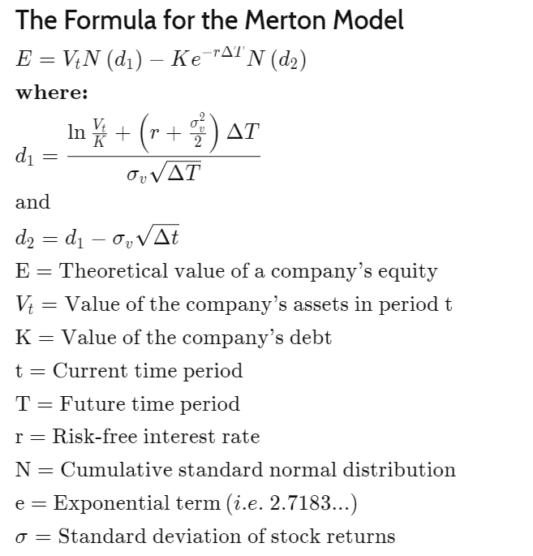

Stock Price

Liabilities on Financial Statements

Asset Values on Financial Statements

We assume geometric Brownian motion for the asset values. The equity value is modelled as a call option. We need the value of the assets and the volatility of the assets to measure d1 and d2. We know the value of liabilities.

The equity is viewed as a European call option on the underlying market value of the firm’s assets, with a strike price equal to the face value of its debt.

We develop a relationship using the Ito’s Lemma:

Volatility of Equity = (Value of Assets/Value of Equity)*d1*Volatility of Assets